Table of content
Sr. No. | Item | Page No
1 | Executive Summary | 2
2 | Chapter 1: Introduction (Company Profile & General Introduction of Topic)  & Objective, Scope and Purpose of Study | 5
3 | Chapter 2: Literature Review | 15
4 | Chapter 3: Research methodology | 22
5 | Chapter 4: Data Analysis | 27
6 | Chapter 5: Findings, suggestions, recommendation | 40
7 | Chapter 6: Conclusion | 48
8 | Bibliography (Books, Journals, research work) | 52
9 | Reference (Website, company paper) | 54
10 | Annexure (A to C) | 56-77
11 | - Questionnaire | 56
12 | - Scope for future study | 62
13 | - Photograph, Drawings | 65

EXECUTIVE SUMMARY

Introduction
India is becoming a more urbanized country, and this has increased demand for healthcare services, especially in metropolitan areas. By 2050, it is expected that there will be 1.77 billion people on the planet, posing unprecedented challenges to the healthcare industry in providing for the demands of a patient population that is becoming more and more complex and diversified. Once a rather simple procedure, hospital administration has evolved into a dynamic and complicated environment that calls for creative solutions to guarantee high-quality patient care, effective resource allocation, and long-term business models.

Objectives
The aim of this study is to examine the present condition of hospital management in urban India and to pinpoint the major obstacles and prospects that will influence its trajectory. The project's goal is to present novel approaches for improving hospital administration's patient-centeredness, effectiveness, and sustainability.

Methodology

1. Review of the literature: Carry out a thorough analysis of the body of knowledge regarding hospital management, Indian healthcare systems, and urban development.
2. Engagement of stakeholders: To get information about the existing situation of hospital administration and upcoming difficulties, interview patients, healthcare professionals, hospital administrators, and legislators.
3. Analysing data: Examine information on patient outcomes, hospital performance, and trends in India's main cities' urban population growth.

Results

Urban India's hospital management is expected to evolve in the future due to a number of reasons, such as changing healthcare objectives, demographic shifts, and technological improvements. Here are a few possible results:

- Digitalization: To increase operational efficiency, promote patient involvement, and streamline administrative processes, hospitals will implement more digital tools and technology.
- Electronic Health Records (EHRs) for precise patient data management are one example of this.
- Telemedicine solutions for patient monitoring and remote consultations.
- Machine learning (ML) and artificial intelligence (AI) for personalized medicine, illness diagnostics, and predictive analytics.

- Data Analytics: Hospitals will use big data and analytics to
- Find patterns and trends in patient care to better allocate resources and achieve better results;
- Create focused marketing campaigns to draw in patients and boost income.
3.Patient-centric strategy: Medical facilities will prioritize providing excellent patient care by:

- Platforms for patient involvement that allow for instant feedback and complaint handling,
- techniques in personalized medicine, include individualized treatment regimens and drug administration.
- greater focus on health literacy and patient education.

4.Workforce management: Hospitals will implement cutting-edge workforce strategies, such as the following:

- Remote work arrangements for healthcare professionals enabled by telemedicine.
AI-powered workforce optimization to guarantee effective resource distribution.
- Online courses to improve healthcare workers' proficiency with cutting-edge technologies

5. Collaborations and partnerships: Urban hospitals may team up with:

- private businesses to create cutting-edge medical products and solutions.
- To exchange best practices, cut expenses, and enhance results with other hospitals.
- Governmental organizations to handle issues related to public health and create policy
6. A greater focus on preventative treatment: Instead of treating acute illnesses, hospitals will treat patients for preventive care, which includes:

- efforts for public health education that encourage healthy lives.
- community-based health initiatives for early illness detection and prevention.
- combining specialist care with primary care services.
7. The introduction of fresh business models: Entrepreneurs, startups, and existing players in the healthcare industry will have new business prospects as telemedicine, digital health platforms, and AI-driven diagnostic tools become more prevalent.

Conclusion
Urban India's hospital administration is expected to undergo a radical makeover in the future due to changes in legislation, patient-centred care, and technology. Navigating these changes and guaranteeing effective, affordable, and high-quality healthcare delivery will be a major responsibility for hospital administrators. The future of healthcare in urban India will be greatly influenced by its ability to embrace innovation and adjust to changing demands.

Suggestions for Future

The future of hospital administration in urban India is poised to undergo significant transformation, driven by advancements in technology, changes in patient expectations, and evolving healthcare policies. Some key suggestions for the future of hospital administration in urban India like usage of digital technologies, patient centric care, Healthcare policies and regulations, Hospital infrastructure, Finance management and sustainability, Employee development. Hospital administrators in metropolitan India can develop a more patient-centred, patient-efficient, and technologically sophisticated healthcare system that adapts to the changing requirements of the populace by concentrating on these areas.

CHAPTER ONE

INTRODUCTION, OBJECTIVES, SCOPE AND PURPOSE OF STUDY

INTRODUCTION

The planned provision of medical services to people or communities with the goal of preserving, enhancing, or regaining physical and mental health is known as healthcare. It includes a wide range of services in the fields of medicine, dentistry, pharmaceuticals, laboratory diagnostics, and support services, all delivered by different specialists. The main objectives of healthcare are to enhance quality of life, prevent and treat diseases and accidents, and promote wellbeing.
Hospital administration is a discipline that has no single "founder," having grown over time as a result of the efforts of numerous people and organizations. Nonetheless, a few important individuals and advancements that profoundly influenced the discipline include as follows:

1820–1910–Florence Nightingale: Florence Nightingale is widely recognized as a trailblazer in the field of hospital administration. Her contributions during the Crimean War and her following endeavours to enhance hospital sanitation and management established the foundation for contemporary hospital administration.

Developments in the Early 20th Century: In the early 20th century, hospital management started to become more formalized. The American College of Healthcare Executives (ACHE) was founded in 1933, which was a big step toward the field's professionalization.
Michael Davis: The study "The Efficiency of the American Hospital," which he published in 1916, brought attention to the necessity of hiring professionals to oversee hospitals and helped establish hospital administration as a distinct field.

Academic Programs: In 1934, the University of Chicago launched the first graduate program in hospital administration. The purpose of this curriculum is to teach people how to run hospitals and other healthcare institutions in an efficient manner.

Professional Organizations: The area of hospital administration was formalized and advanced with the founding of organizations like the American Hospital Association (AHA) in 1898 and the ACHE.
All things considered, the field of hospital management developed as a result of the combined efforts of numerous people, organizations, and institutions, each of which contributed to its advancement and professionalization.
Managing and supervising a hospital's or healthcare facility's activities is known as hospital administration. It includes a broad range of duties intended to guarantee the efficient and successful provision of healthcare services. Important facets of hospital management consist of:
1. Management of Operations:

- making certain that the hospital functions properly every day.
- coordinating with several departments, including emergency services, nursing, surgery, and administrative support.

2. Financial supervision:
In hospital administration, financial management is essential since it provides the foundation for providing high-quality care and ensuring the long-term viability of healthcare services. Hospital administrators must effectively allocate resources, maintain cost-effectiveness, and maximize revenue generation in this changing environment, all of which have a direct and significant impact on patient outcomes. Administrators must prioritize investments in healthcare staff and technologies, manage budgets expertly, and use creative financial techniques in order to meet these goals. They must make sure that every financial choice they make enhances the quality of care given to patients by keeping services accessible and affordable. Furthermore, strong financial management is necessary to promote collaborations, advance R&D, and eventually improve healthcare organizations' overall performance.
Key factors in healthcare financial management include cost-effectiveness and financial sustainability. Maintaining the quality of patient care while keeping expenses under control is a constant problem for hospitals. It is the responsibility of healthcare managers to put cost-cutting measures in place that protect patient safety and uphold high standards of care. To further explain, reaching these objectives can require a number of crucial tactics, with a particular emphasis on supply chain management optimization, favourable vendor contracts, and process upgrades to reduce waste. Hospitals can improve demand forecasting, expedite procurement procedures, and optimize supply chain management by implementing effective inventory control systems. By making sure that required medical supplies and equipment are on hand when needed, hospitals may cut down on needless storage expenses and lower the chance of shortages that could jeopardize patient care. Negotiating advantageous vendor agreements to obtain competitive price and quality assurances can also be an effective strategy for supply chain management, ultimately resulting in lower expenses.
- Human Resources:

Positive patient outcomes in the healthcare industry are greatly influenced by human resource management. Hospital administrators must strategically manage their staff in order to guarantee that medical staff members are not only qualified but also driven and enthusiastic about providing patients with the best care possible [12]. Staffing and workforce planning are the cornerstones of good human resource management in this environment. The best possible balance of medical professionals, including doctors, nurses, allied health professionals, and support personnel, must be maintained by the hospital, and this is the responsibility of the administration. Achieving this ideal blend and matching of skills is necessary for providing patients with timely and efficient care. Forecasting the hospital's personnel needs, which are impacted by patient volumes, acuity, and specialty requirements, is part of strategic workforce planning. Administrators should proactively address concerns such as understaffing or overstaffing by matching staffing levels with patient demand. This will optimize resource usage and eventually improve patient outcomes.
4. Assurance of Quality and Safety of Patients:
Hospital management is not complete without addressing quality improvement and patient safety. Reaching these goals requires taking particular actions. These actions are essential for improving patient outcomes and guaranteeing the provision of high-caliber, safe, and efficient medical treatment. Hospital administrators play a critical role in advancing these initiatives. Metrics and measurement related to quality are essential for assessing and improving patient outcomes. To track different quality metrics, hospital administrators should set up thorough performance measuring systems. These measures include patient satisfaction, clinical results, and other relevant activities. They also cover adherence to best practices. They are essential instruments for assessing the efficacy of healthcare services and identifying areas in need of improvement. Administrators can gain important insights into the hospital's performance and subsequently spearhead ongoing quality improvement initiatives by routinely gathering and evaluating data regarding patient care. These programs cover a wide range of tasks, including as decreasing adverse occurrences, improving clinical procedures, and allocating resources optimally to improve patient outcomes. Hospital management is fundamentally impacted by patient safety protocols and efforts. Administrators of hospitals are required to create and uphold comprehensive safety procedures that cover a range of patient care issues. This covers projects like drug reconciliation, infection control strategies, programs to avoid falls, and use of evidence-based healthcare guidelines. Administrators can drastically lower adverse events, medical errors, and patient injury by placing a high priority on patient safety. These initiatives not only improve treatment outcomes but also help patients and their families gain confidence.
5. Adherence to Regulations:

- ensuring that the hospital abides by all applicable national, state, and local laws.
- keeping up accreditation from pertinent medical associations.

6. Planning Strategically:

- establishing long-term objectives and plans for the hospital.
- recognizing chances for development and enhancement.
- introducing novel ideas and technology to the healthcare industry.
7. Facilities Administration:

- keeping up the hospital's physical infrastructure.
- guaranteeing the accessibility and efficiency of medical facilities and equipment.

8. Public affairs and community relations:

- establishing and preserving connections with the neighbourhood, the government, and other relevant parties.
- Overseeing communication and public relations tactics.

9. Information Administration:

- monitoring health information systems and guaranteeing the security and integrity of data.
- leveraging data analytics to enhance patient care and hospital performance.

OBJECTIVES

Patient Care Quality: Make sure that patient safety and care are up to the highest standards.
Operational Efficiency: Reduce waste and maximize efficiency in hospital operations.
Financial Management: To guarantee the hospital's long-term survival, uphold a sustainable financial model.
Legal and Regulatory Standards: Comply with all applicable laws, rules, and accreditation requirements.
Management of Human Resources: Drawing in, keeping, and developing qualified medical personnel.
Technology Integration: To enhance patient care and operational effectiveness, implement and oversee technological solutions.
Community Health: Encourage programs for preventative care and community health initiatives.
Customer Satisfaction: Make sure that patients and their families are highly satisfied.
Long-term strategic plans should be created and put into action to direct the hospital's expansion and enable it to adjust to the evolving healthcare environment.
The goal of risk management is to recognize and reduce threats to hospital operations, patient safety, and financial stability.

SCOPE

Clinical Services Management: Supervising the provision of clinical services and guaranteeing adherence to safety and quality guidelines.
Financial management: includes revenue cycle management, accounting, financial planning, and budgeting.
Management of Human Resources: hiring, training, employee relations, and performance evaluation.
Facility management: is the upkeep of the physical infrastructure of hospitals, such as its structures, furnishings, and supplies.
Information technology management: includes setting up and keeping up telemedicine, electronic health records (EHR), and other IT systems.
Taking care of patient records, billing, admissions, and discharges is known as patient administration.
Quality assurance: is the process of keeping an eye on and enhancing the standard of care via a range of initiatives and activities.
Regulatory Compliance: Making sure that laws, rules, and standards pertaining to healthcare are followed.
Strategic planning and development: includes making plans for upcoming initiatives, growing, and adjusting to shifting healthcare delivery paradigms.
Public relations and community outreach include fostering ties with the neighbourhood, upholding the hospital's reputation, and taking part in activities that promote community health.
Supply Chain Management: Supervising the Acquisition and Administration of Both Non-Medical and Medical Supplies.
Patient safety and risk management: creating and putting into practice policies to improve patient safety and manage hazards.

Comprehensive Dissection

1. Quality of Patient Care
- Create guidelines and standards of care.
- Track the satisfaction and results of your patients.
- Put initiatives for continual improvement into action.
2. Efficiency of Operations

- Simplify procedures to cut down on wait times.
- Maximize staff and resource use.
- Put lean management techniques into action.

- Money Handling

- Create and oversee budgets.
- Make forecasts and analyses of finances.
- Control the processes for coding, billing, and reimbursement.

- Observance of Laws and Regulations

- Make sure all federal, state, and local laws are followed.
- Retain certification from appropriate organizations.
- Put in place confidentiality and privacy policies (like HIPAA).

- Management of Human Resources

- Create job descriptions and hiring tactics.
- Implement professional development and training initiatives.
- Implement initiatives for staff retention and well-being.

- Integration of Technology

- Control other health IT systems as well as EHRs.
- Put telehealth and remote monitoring systems into practice.
- Ascertain the presence of cybersecurity safeguards.

- Public Health

- Plan programs for health education and screening.
- Work together on public health initiatives with neighbourhood organizations.
- Utilize outreach initiatives to address social determinants of health.

- Client Contentment

- Survey satisfaction from patients and their families.
- Respond quickly to comments and grievances.
- Improve the patient experience by taking different steps.

- Methodical Scheduling

- Examine healthcare demands and market trends.
- Create long-term targets and goals.
- Make plans for new service lines and facility expansions.

- Hazard Assessment

- Determine possible hazards and create plans for preventing them.
- Organize routine safety exercises and instruction.
- Handle liabilities and insurance concerns.

PURPOSE
Technological developments, policy changes, and evolving healthcare requirements are expected to bring about a considerable transition in hospital administration in urban India in the future. The main elements and goals of this progression are as follows:
1. Improving Care Quality and Efficiency
Digital Health Records: By using Electronic Health Records (EHRs), patient information management will be more efficient, errors will be decreased, and service continuity will be enhanced.
Telemedicine and Remote Care: By enabling remote consultations, telemedicine services can be expanded, improving accessibility to healthcare and relieving pressure on urban hospitals.
2. Using Cutting-Edge Technologies
AI and machine learning: AI can help with tailored treatment plans, diagnostics, and predictive analytics, which can improve clinical decision-making and operational effectiveness.
Automation and Robotics: Using automated technologies for administrative work and robotics for surgical procedures will increase accuracy and productivity.

3. Promoting Care That Is Patient-Centred

Patients will be able to better manage their health, make appointments, view their medical records, and get in touch with healthcare professionals thanks to patient portals and mobile health apps.
Personalized medicine: It will become more common to customize therapies based on each patient's unique genetic profile and medical records.
4. Enhancing Facilities and Abilities
Smart Hospitals: By incorporating IoT (Internet of Things) devices, smart beds, and real-time monitoring systems into their infrastructure, hospitals may improve both patient care and hospital administration.
Capacity Management: Managing the growing urban population will need the use of advanced analytics to forecast patient admissions and improve resource allocation.

5. Making Public Health Systems Stronger
Integrated Healthcare Systems: Improving patient outcomes and resource efficiency can be achieved by establishing a smooth integration across the primary, secondary, and tertiary care levels.
Policy Reforms and Public-Private Partnerships: Promoting cooperation between public and private sectors will enhance the infrastructure and delivery of healthcare.

6. Handling Issues with the Healthcare Workforce
Training and Education: To stay up to date with emerging technology and techniques, healthcare professionals should participate in ongoing professional development and training programs.
Workforce Management: Using AI to schedule and manage the workforce in order to minimize burnout and guarantee ideal staffing levels.
7. Maintaining Financial Stability
Health Insurance and Payment Models: Value-based care models and increased insurance coverage will contribute to more inexpensive and long-lasting healthcare.
Cost management is the process of putting cost-effective procedures into place and cutting waste by using effective hospital administration systems.

8. Pay attention to wellness and preventive care
Community Health Initiatives: To lower the prevalence of chronic diseases, promoting preventative care through wellness programs, health education, and community outreach program
9. Data-Driven Health Interventions: These involve identifying health trends and putting specific health interventions into action using big data and analytics.

The goal of hospital management in urban India going forward is to develop a healthcare system that is more patient-centred, technologically sophisticated, and efficient. Hospital administrators may guarantee enhanced patient satisfaction, better health outcomes, and sustainable healthcare delivery in metropolitan locations by adopting these reforms.

CHAPTER TWO
LITERATURE REVIEW

LITERATURE REVIEW
In urban India, a number of important issues will influence hospital management in the future: changing patient demographics, governmental and regulatory changes, technological improvements, and the demand for better healthcare delivery models. These elements are examined in this literature study along with how they affect hospital administration in India's cities.
1. Technological Progress
a: Telemedicine and Digital Health
Telemedicine: The COVID-19 epidemic has sped up the implementation of telemedicine by lowering the necessity for in-person visits and facilitating remote consultations. Research indicates that telemedicine, which provides accessibility and convenience, will continue to play a significant role in the delivery of healthcare in metropolitan areas.
Electronic Health Records (EHR): Streamlining hospital operations, enhancing patient care, and improving data accessibility and accuracy all depend on the integration of EHR systems. There have been large expenditures in health information technology during this continuing change.
AI and machine learning: Predictive analytics, patient management, and decision support systems are three areas where AI-powered solutions are being utilized more and more. These technologies can improve diagnosis accuracy, forecast patient outcomes, and allocate resources optimally.
b. Automation and Robotics
Surgical Robots: With its precision and quicker recovery times, robotic surgery is becoming more and more popular. There's a good chance that more hospitals will invest in robotic technology in the future.
Automation in Administration: Automating regular administrative duties can increase productivity, cut down on errors, and save time. Automation in billing and chatbots for patient requests are examples of the technologies that are becoming increasingly widespread.

2. Modifications to Policies and Regulations
a. Reforms to Healthcare Policy
Ayushman Bharat Scheme: This national health protection program intends to cover millions of low-income households for medical expenses. As a result, it will affect hospital administration by increasing patient volume and requiring effective resource management.
Normative Guidelines: Ensuring patient safety and excellent care through the strengthening of regulatory frameworks is a top focus. Hospital administrators are finding it more and more crucial to adhere to standards like those set by NABH (National Accreditation Board for Hospitals & Healthcare Providers).
b. PPPs, or public-private partnerships
Collaboration Models: PPPs are necessary to improve the services and infrastructure of the healthcare industry. Effective models promote improved resource utilization and service delivery by having the public and private sectors share investments and responsibilities.

3. Changing Patient Profiles
a. The aging population
Geriatric Care: As the number of senior citizens rises, so does the demand for specialist geriatric care. Hospital managers must modify services, such as palliative care and chronic illness management, to meet the special needs of senior citizens.
b. Lifestyle Illnesses and Urbanization
Non-communicable diseases (NCDs): Diabetes, hypertension, and cardiovascular disorders are among the NCDs that are on the rise as a result of urban lifestyles. Hospitals need to develop dedicated departments and preventive care initiatives to better address these illnesses.

4. Models of Healthcare Delivery
a. Patient-centred care
Personalized Medicine: Treatments can now be customized to each patient's unique profile thanks to developments in genomes and biotechnology. Strong data management systems and interdisciplinary cooperation are necessary for this strategy.
Integrated Care Models: Ensuring comprehensive treatment and enhancing patient outcomes are achieved by coordinating care across several disciplines and services. Increasingly, integrated care approaches are being used to improve patient satisfaction and expedite services.
b. Healthcare Based on Value
Cost-Effectiveness: The emphasis in the transition from volume-based to value-based healthcare is on results and economy. Hospital managers are concentrating on leveraging technology and effective management techniques to cut expenses while raising quality.

HISTORICAL ASPECTS
A number of historical factors that have shaped the growth and direction of hospital administration in urban India will continue to have an impact in the future. These elements include changes in socioeconomic conditions, the creation of medical infrastructure, the evolution of healthcare legislation, and advances in technology. The following significant historical elements will affect hospital administration in urban India going forward:
1. Early Developments and the Legacy of Colonialism
Colonial Era: Western medical practices, hospitals, and medical colleges were established during the British colonial era in India, which created the groundwork for the country's current healthcare infrastructure.
Post-Independence Era: In order to meet the health demands of its sizable population, India concentrated on developing a public healthcare infrastructure after obtaining independence in 1947.
2. Reforms and Policy Initiatives
Five-Year Plans: Since the 1950s, the Indian government has regularly included healthcare development in its Five-Year Plans, placing a strong emphasis on the construction of hospitals, the expansion of medical education, and the enhancement of public health services.
National Health Policy: Aiming for fair access to healthcare services and universal health coverage, the National Health Policy was first introduced in 1983 and has since been amended. It has directed the strategic direction for healthcare delivery.

3. Increasing Access to Medical Education
Medical Colleges and Institutions: The proliferation of medical colleges and institutions in metropolitan areas has expanded access to skilled healthcare workers, which has enhanced hospital management and administration.
Specialization and Super-Specialization: The construction of cutting-edge medical facilities and services in metropolitan hospitals is a result of the expansion of specialized and super-specialized medical education.

4. Developments in Technology
Digital Health Initiatives: By improving productivity, patient care, and data management, the advent of digital health initiatives—such as telemedicine, electronic health records (EHR), and mobile health applications—has completely changed hospital administration.
Medical Technology: The use of robotic surgery, minimally invasive procedures, and diagnostic imaging has revolutionized clinical practices and hospital administration.

5. Economic Liberalization and the Engagement of the Private Sector
1991 Economic Reforms: Private sector investment in healthcare was made easier by the early 1990s economic liberalization policies, which resulted in the construction of multiple private hospitals and healthcare chains in urban regions.
Public-Private Partnerships: Working together to enhance healthcare services and infrastructure, the public and private sectors have become increasingly important.

6. Urbanization and Changes in the Population
Rapid Urbanization: Due to India's substantial urbanization, there is a greater need for healthcare services in urban areas, which has prompted hospitals to expand and modernize in order to serve these populations.
Aging Population: As a result of the demographic trend toward an aging population, urban hospitals now offer specialist geriatric care and chronic illness management.

7. Healthcare Issues and Reactions
Epidemics & Pandemics: Past health crises, including the COVID-19 pandemic and the HIV/AIDS epidemic, have highlighted the significance of strong hospital management, emergency planning, and efficient public health measures.
Health Inequities: Reducing health disparities is still very important, and urban hospitals are essential in helping underprivileged populations get access to high-quality, reasonably priced treatment.

FUTURE PROSPECTS

- Given these historical impacts, hospital administration in India's cities is expected to concentrate on the following in the future:
- Improved Technology Utilization: Greater use of big data analytics, machine learning, and artificial intelligence (AI) to provide more individualized patient care and better decision-making.
- The creation of integrated health care systems that guarantee smooth communication between primary, secondary, and tertiary care providers.
- Sustainable Healthcare activities: Hospital administration places a strong emphasis on ecologically friendly and sustainable activities.
- To guarantee ethical behaviours, patient safety, and high standards in hospital administration, policy and regulatory frameworks should be strengthened
- Building Capacity and Training: To keep up with changing healthcare trends and technologies, healthcare administrators should participate in ongoing professional development and training programs.
- The previously mentioned historical features offer a fundamental basis for understanding the evolution of hospital management in metropolitan India, emphasizing the complex relationship between historical advancements and forthcoming improvements.
- Machine learning and artificial intelligence (AI) integration in healthcare administration has a lot of potential and real-world applications. To help with data analysis, predictive analytics, and administrative process automation, hospitals may want to explore investing in AI-driven solutions. AI, for example, can better allocate resources, optimize staff schedules, and forecast patient admission rates. AI can also help with invoicing, medical coding, and claims processing, which can decrease errors and increase efficiency. It is recommended that hospitals develop comprehensive AI deployment methods in order to ensure successful integration. This entails determining the fields in which artificial intelligence can be most helpful, establishing performance standards, and creating training courses to help employees use AI products efficiently. It is crucial to ensure that ethical principles and data privacy are respected while using AI technologies, necessitating strict adherence to ethical rules and strong data protection mechanisms.
- Blockchain: With its increased security and openness, blockchain technology presents a fresh method for managing medical data. Blockchain applications for billing, supply chain management, and patient record-keeping should be investigated by hospitals. Hospitals should work with blockchain specialists to address this technology, put strong blockchain solutions into place, and train staff members on blockchain fundamentals. Maintaining patient trust requires utilizing blockchain technology to ensure compliance with data privacy standards. Telehealth and remote monitoring: A revolutionary development in healthcare administration is the growth of telehealth services and the use of remote monitoring tools. When assessing the integration of these technologies, there are a number of strong advantages and possible disadvantages to take into account in addition to the requirement that "they should". Improved patient access to care, particularly for those living in rural or underserved areas, lower healthcare expenditures, and better monitoring and management of chronic illnesses are some advantages of telehealth and remote monitoring. Furthermore, by cutting down on in-person visits and waiting periods, telehealth can improve the efficiency of healthcare facilities. It also provides the flexibility of virtual consultations, which can be especially helpful in times of public health emergencies. But it's important to recognize the possible difficulties and disadvantages. Due to worries about data security and privacy, legal and licensing challenges, and the requirement for significant investments in technology and training, some healthcare facilities may be reluctant to implement telehealth. Furthermore, not every medical condition may be successfully treated with virtual care, and in-person assessments and treatments may not always be possible. Regulatory frameworks, patient demographics, infrastructure, and financial resources all have a role in whether or not telehealth technologies are adopted. To make an informed choice about their implementation, it is crucial to thoroughly evaluate these factors in light of the particular conditions of each
- Health care Robotic Process Automation (RPA): RPA has the ability to streamline administrative duties like making appointments and processing claims. RPA can help hospitals by lowering error rates and increasing productivity. Hospitals should find applications for robotic process automation (RPA), put RPA technologies in place, and train employees who will be interacting with automated procedures to solve this. To guarantee accuracy, RPA systems need to be regularly monitored and audited.
- The use of the Internet of Things (IoT) in healthcare can improve patient safety and resource management by enabling real-time patient and medical equipment monitoring. Hospitals ought to make investments in analytics power, safe data transfer, and IoT infrastructure. Managing IoT security issues and guaranteeing patient data privacy and security are crucial factors to take into account.
- Big data and analytics: Enhancing patient outcomes, allocating resources, and controlling costs all depend on the analysis of massive amounts of healthcare data. Hospitals ought to make data governance policy, hire qualified data analysts, and invest in data analytics tools. Furthermore, when utilizing big data analytics, hospitals should put patient trust first by prioritizing data protection and security.

CHAPTER THREE
REASEARCH METHODOLOGY

REASEARCH METHODOLOGY

Issues specific to research in administration include the dearth of testable hypotheses and the suggestion that the results of this kind of study should be quickly implemented to the program being examined. In order to create testable hypotheses, numerous preliminary administrative studies must be conducted in order to solve the first issue. After that, planned experiments may be conducted. It's possible that compromise will be the only way to solve the second issue.
Researchers may need to be satisfied when their findings are applied to other comparable programs rather than the programs they are studying if we are truly trying to produce new knowledge. The results of valid administrative research may cause human stress that inhibits program directors from implementing the findings because they are upset by them. Taking a different approach and turning the project into an exercise in altering one's mindset frequently yields results that are not very useful in general. The following issues arise when research methodologies are applied to administration:
• There are several unclear parameters, assumptions, and definitions.
• It is challenging to keep a lot of variables constant. Therefore, results that are interpreted too broadly may be implausible.
• There aren't many testable hypotheses given. When starting an administrative research program, it is important to first identify a plausible study area and then create techniques for gauging the program's impact.

The goal of hospital administration research

Hospital administration research focuses on the methods used to deliver hospital services as well as any variables that may affect these methods.
New information about organizations, activities, personnel involved, and the people or communities they serve is created through administrative research. Hospital administrative studies tend to concentrate on these topics, with patients and diseases being secondary concerns that occasionally serve as benchmarks for evaluating the efficacy of patient treatment. Human motivation and behaviour, the financial outcomes of initiatives, the pattern and effects of managerial choices, the gathering and analysis of disease data, and statistics. Administrative research encompasses a wide range of topics, including operational administration and physical facilities.
The development of norms, standards, and a sequence of progressive guidelines against the shortcomings of hospital management is another goal of administrative research. These prescriptions from past years were based on extensive experience and occasionally on common sense, neither of which holds up over time. especially, into the application of principles drawn from science in administration. Therefore, the aim of administrative research is to ingrain new scientific ideas within the empirical underpinnings.
TYPES OF RESEARCH

The degree of abstract reasoning that underpins each sort of inquiry allows for differentiation. Three categories of research exist:
Finding of Facts
The primary goal in this kind of work, as in sociological surveys, is to obtain facts. It makes use of "Primary Data” techniques, such as the Reserve Bank of India's Rural Credit Survey."
Interpret already available information
This basically interprets data that is already accessible. It takes a bibliographical approach, meaning that "secondary data"—information gathered by other researchers—is used.
The focus is mostly on the analysis and interpretation of current data.
Studies in the Only-Theorizing Category
The fundamental idea behind this kind of theory is the construction of increasingly abstract levels of pure theory, sometimes grounded in pure reasoning and other times in remote primary and secondary evidence.
Health departments typically start research planning in one of two ways:
The solo strategy involves individuals focusing on certain issues and conducting research apart from other health department activities. Eventually, it can lead to the creation of a central coordinating mechanism inside a major department in order to get rid of redundant research activity.
the integrated strategy, which uses a small team to encourage and assist others in creating potentially relevant research topics.
1. Define Research Objectives Identify Key Areas: Focus on technological advancements, policy changes, demographic shifts, financial models, and patient care innovations. Set Clear Goals: Determine what specific aspects you want to explore, such as efficiency improvements, cost reductions, or patient outcomes.
2. Identify Data Sources Academic Journals:
Use databases like PubMed, JSTOR, and Google Scholar to find peer-reviewed articles on hospital administration trends.
Industry Reports: Look for reports from healthcare consulting firms (e.g., McKinsey, Deloitte, PwC) and market research firms.
Government Publications: Review reports and statistics from health departments, WHO, CDC, and other relevant agencies.
Professional Associations: Check publications from organizations like the American Hospital Association (AHA) and the Healthcare Information and Management Systems Society (HIMSS).
News Outlets and Magazines: Look for relevant articles in healthcare-focused news sources like Modern Healthcare and Health Affairs.
Books and E-books: Find books that discuss the future of healthcare and hospital administration.
3. Data Collection Literature Review:
Collect and review the most relevant and recent literature on the subject.
Extract Key Information: Focus on findings, methodologies, trends, and expert opinions.
Note Contradictions and Gaps: Identify areas where studies disagree or where there is a lack of information.
4. Data Analysis Thematic Analysis:
Group the findings into themes such as technological advancements, policy changes, financial strategies, and patient care improvements.
Trend Analysis: Identify trends and patterns in the data.
SWOT Analysis: Assess strengths, weaknesses, opportunities, and threats related to future hospital administration.
5. Synthesis and Interpretation Integrate Findings:
Combine insights from different sources to form a cohesive understanding.
Draw Conclusions: Summarize the key points and trends that emerge from the analysis.
Predict Future Developments: Based on the findings, predict possible future scenarios and implications for hospital administration.
6. Reporting Write a Report:
Present the findings in a structured format with clear sections for each theme and trend.
Use Visual Aids: Include charts, graphs, and tables to illustrate key points.
Provide Recommendations: Based on the analysis, offer actionable recommendations for hospital administrators.
Summarize findings in a comprehensive report.
Highlight key trends, challenges, and future directions in hospital administration.
Provide actionable recommendations for stakeholders.
Example Areas of Focus:
Technological Advancements: AI, telemedicine, electronic health records (EHR), robotics.
Policy Changes: Impact of healthcare reforms, regulations, and accreditation standards.
Demographic Shifts: Aging population, urbanization, and changing patient expectations.
Financial Models: Value-based care, alternative payment models, and cost-containment strategies.
Patient Care Innovations: Personalized medicine, patient-centred care, and integrated care models.
By following this methodology, you can gain a comprehensive understanding of the future of hospital administration, leveraging existing knowledge to inform strategic planning and decision-making.

CHAPTER FOUR
DATA ANALYSIS

DATA ANALYSIS

Data analysis was done using Government reports
Academic research papers and journals
Industry reports (e.g., McKinsey, Deloitte)
Online articles and news stories
Surveys and interviews with hospital administrators, clinicians, and patients with the help of online survey applications.
Data from healthcare analytics platform
Health care personnel and different areas inside the health care centre were separated using filters, and the collected data was tabulated, averages were found, and certain results were displayed in pictorial form. The questionnaire data were analysed after being grouped and analysed independently. The questionnaire questions were chosen so that the answers demonstrated awareness of healthcare as well as importance of hospital administration. The compliance study's data was categorized and assessed independently in order to derive a number of inferences from the findings.

DATA ANALYSIS

Online survey was conducted to know more about hospital administration. In this survey around 130 people participated from different age group.
Among them 25 are Health care workers.

GENDER DISTRIBUTION

Males 84
Females 46

GENDER DISTRIBTION
130 people were participated in this online survey of which 46 were females and the rest 84 males.

AGE AND GENDER DISTRIBUTION

TABLE DEPICTING AGE & GENDER

S/NO. | AGE RANGE | MALE | FEMALE
1 | 20-25 | 5 | 2
2 | 26-30 | 8 | 9
3 | 31-35 | 15 | 10
4 | 36-40 | 9 | 6
5 | 41-45 | 20 | 7
6 | 46-50 | 18 | 5
7 | 51-55 | 6 | 4
8 | 56-60 | 3 | 2
9 | 61 and above | 0 | 1

EXPERIENCE AND GENDER

Chart and table showing age and experience among the health care workers
S/NO. | EXPERIENCE | MALE | FEMALE
1 | < 2 | 0 | 1
2 | 2-5 | 1 | 2
3 | 5.1-10 | 4 | 6
4 | 10.1-15 | 2 | 3
5 | 15.1-20 | 2 | 3
6 | >20 | 0 | 1

RESPONSES TO THE QUESTIONNAIRE

HEALTHCARE WORKERS RESPONSES TO THE QUESTIONNAIRE

S/NO. | QUESTIONS | RESPONSES
1 | Safe working environment | Y 20/80% N 5/20%
2 | Adequate staffing available | Y 15/60% N 10/40%
3 | Healthcare benefits such as fair pay, healthcare coverage | Y 4/16% N 21/84%
4 | Training programs | Y 22/88% N 3/12%
5 | Effective communication and transparency | Y 16/64% N 9/36%
6 | Policies that support work-life balance | Y 3/12% N 22/88%
7 | Acknowledgment | Y 15/60% N 10/40%
8 | Support from administration to prioritize patient care  Over administrative burdens | Y 13/52% N 12/48%
9 | Respectful and supportive work culture | Y 16/64% N 9/36%
10 | Has covid affect on administration | Y 23/92% N 2/8%
11 | Suggestions | RECORDED

ANALYSIS OF RESPONSES TO QUESTIONNAIR

S/NO. | QUESTIONS RESPONSES TO QUESTIONNAIRE | SCORE
1 | There is safe working environment | 80%
2 | Adequate staffing is available | 60%
3 | Healthcare benefits | 16%
4 | Training programs available | 88%
5 | There is effective communication and transparency | 64%
6 | Policies that support work-life balance | 12%
7 | Acknowledgment | 60%
8 | There is Support from administration to prioritize patient care  Over administrative burdens | 52%
9 | Respectful and supportive work culture | 64%
10 | Covid has effects on administration | 92%
 | TOTAL SCORE | 58.8%

PATIENTS, RELATIVES RESPONSES TO QUESTIONNAIRE AND ANALYSIS

- How is the billing system in Hospitals?

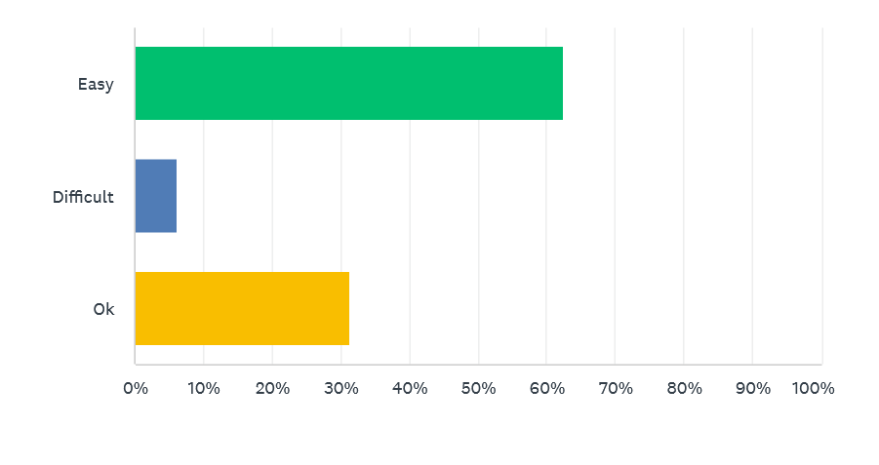

ANSWER CHOICES | RESPONSES
Easy | 62.50%
Difficult | 6.25%
Ok | 31.25%

- Were hospital staff members clear and respectful in their communication with you and your family?

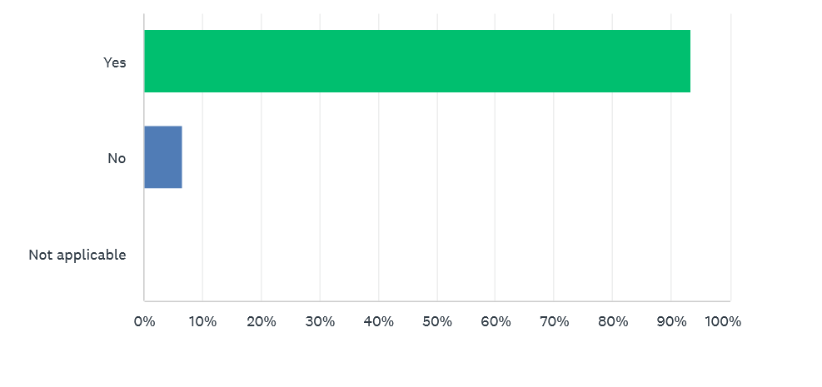

ANSWER CHOICES | RESPONCES
Yes | 93.33%
No | 6.67%
Not applicable | 0.00%
- Did you receive timely updates on your medical condition and treatment progress?

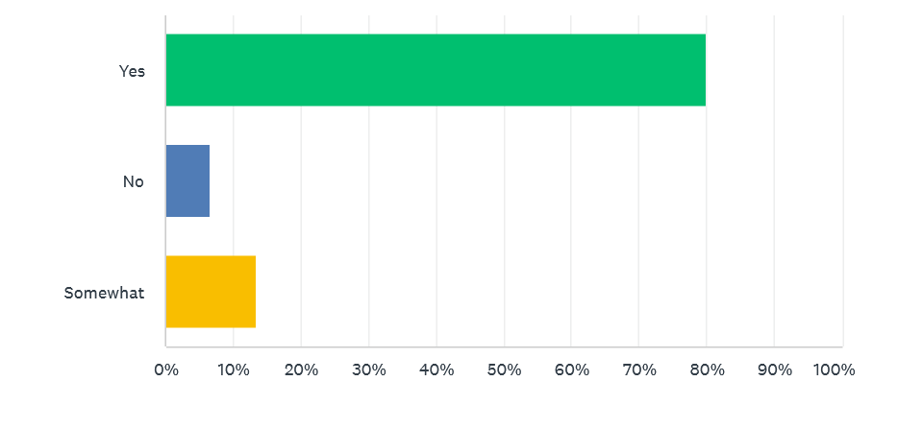

ANSWER CHOICES | RESPONSES
Yes | 80.00%
No | 6.67%
Somewhat | 13.33%

- Did you feel that your medical needs were adequately addressed by the healthcare providers?

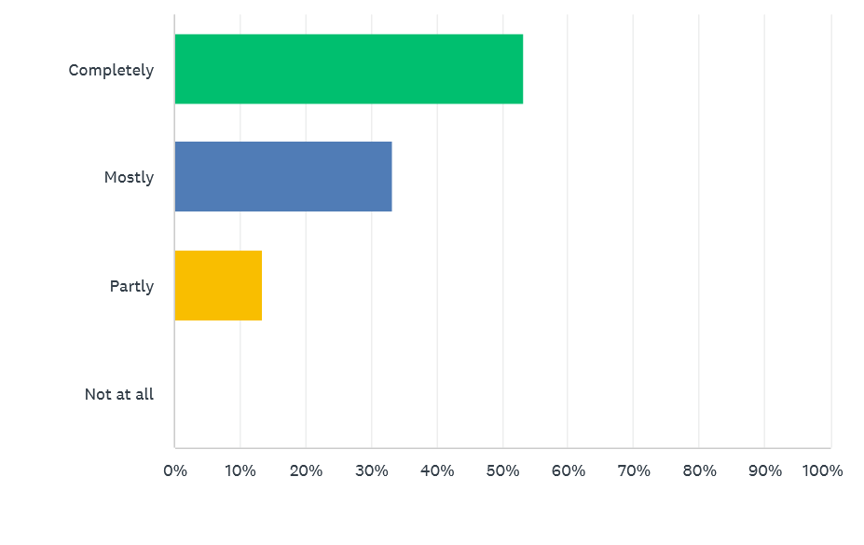

ANSWEE CHOICES | RESPONSES
Completely | 53.33%
Mostly | 33.33%
Partly | 13.33%

- Were you informed about the potential risks and benefits of your treatment options?

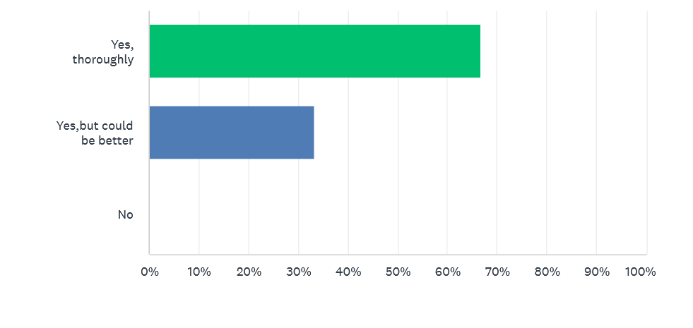
ANSWER CHOICES | RESPONSES
Yes, thoroughly | 66.67%
Yes, but could be better | 33.33%
No | 0.00%

- Were there enough nurses and support staff available to assist you during your stay?
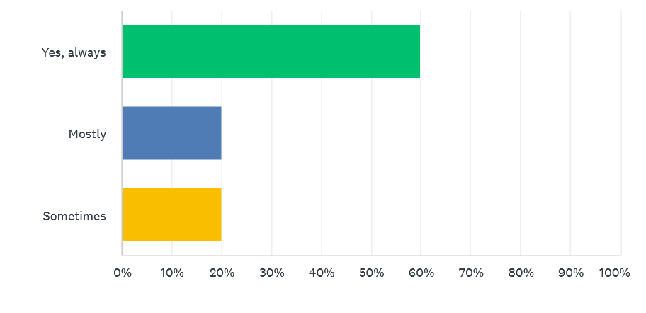

ANSWER CHOICES | RESPONCES
Yes, always | 60%
Mostly | 20%
Sometimes | 20%

- How important do you think technological advancements such as Al, telemedicine, and digital health records will be in shaping the future of hospital administration in urban India?
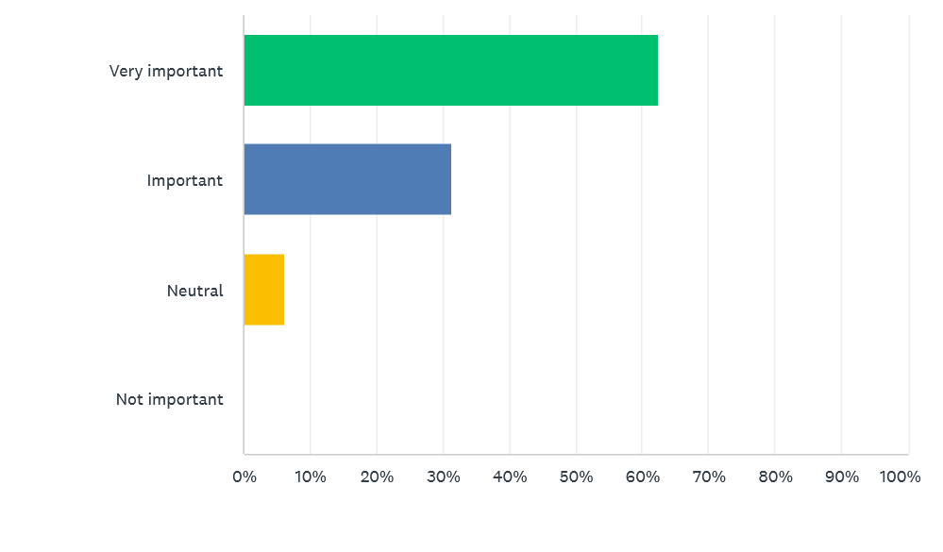
ANSWER CHOICES | RESPONCES
Very important | 62.50%
Important | 31.25%
Neutral | 6.25%

- In your opinion, what are the key challenges that hospitals in urban India will face in the next. decade?

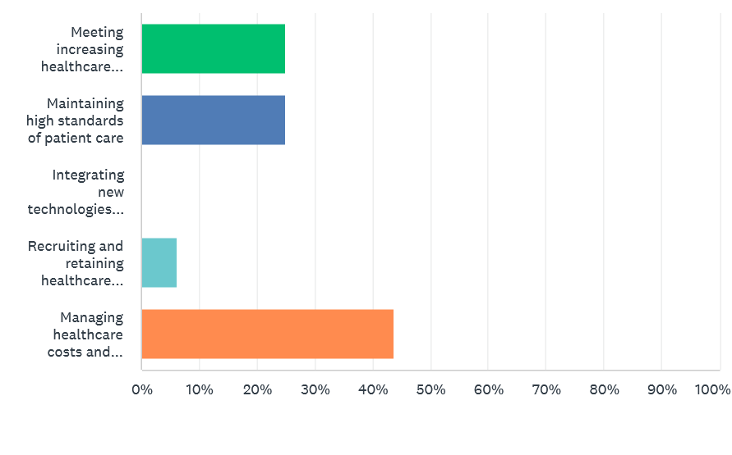
ANSWER CHOICES | RESPONSES
Meeting increasing healthcare demands | 25%
Maintaining high standards of patient care | 25%
Managing healthcare costs and affordability | 43.75%
Recruiting and retaining healthcare professionals
- How satisfied are you with the current level of patient care and service delivery in hospital in urban India?
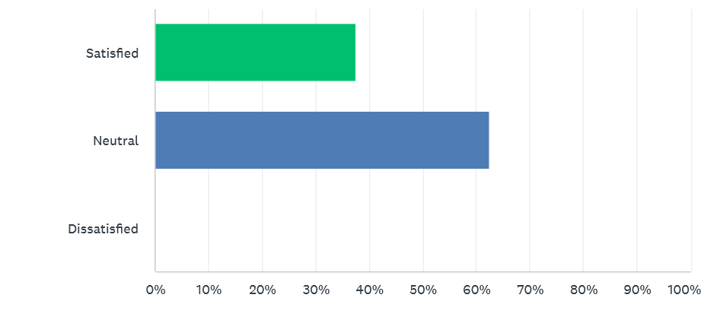

ANSWER CHOICES | RESPONSES
Satisfied | 37.50%
Neutral | 62.50%
Dissatisfied | 0.00%

- Do you believe hospitals in urban India are adequately prepared to handle public health crises or emergencies in the future?

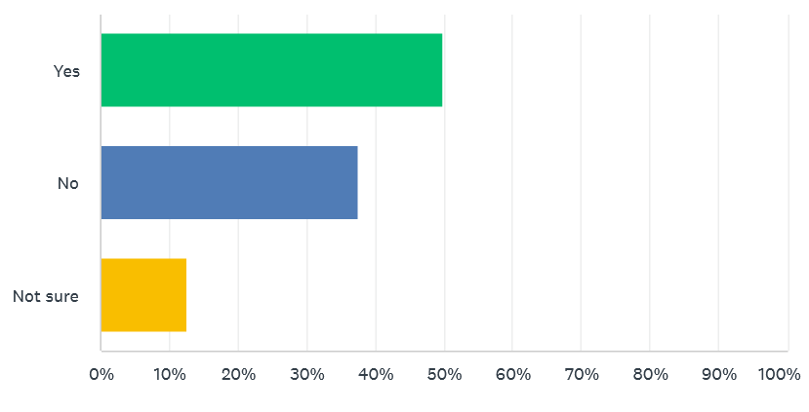

ANSWER CHOICES | RESPONSES
Yes | 50%
No | 37.50%
Not sure | 12.50%

- How important is it for hospitals to focus on environmental sustainability and reduce their carbs footprint in urban India?
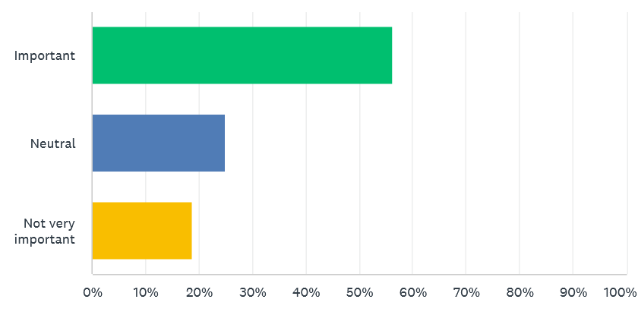

ANSWER CHOICES | RESPONSES
Important | 56.25%
Neutral | 25%
Not very important | 18.75%

- How optimistic are you about the future of hospital administration in Urban India?

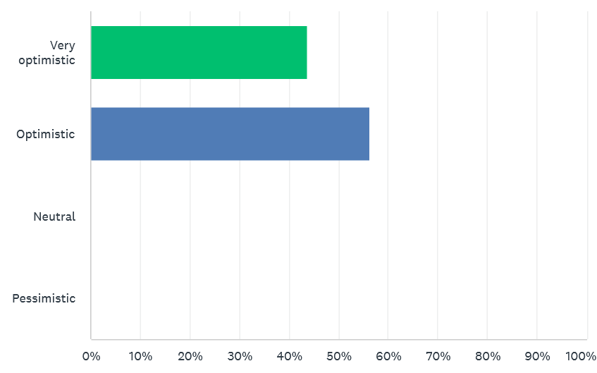

ANSWER CHOICES | RESPONSES
Very optimistic | 43.75%
Optimistic | 56.25%
Neutral | 0.00%
Pessimistic | 0.00%

CHAPTER FIVE

FINDINGS, SUGGESTIONS AND RECCOMENDATIOM

FINDINGS

From analysis the following findings was arrived at

130 people were participated in online survey among them 25 were health care
workers

80.77% were patients, relatives and others. 19.20% were health care workers including
Doctors, nurses, other staff from health care industry.
Among them 84 (64.62%) respondents were male while 46 (35.38%) respondents were
females.
Age-wise the youngest was 22 years, and oldest was 66 years.
5.38% are below 25 years, 13.07% are 26 -30 years, 19.23% are between 31&35, 11.54%
are between 36&40 years, 20.77% are between 41&45 years, 17.69% are between 46&50,
7.69% are between 51&55 years, 3.84% between 56&60, while 00.76% are above 60 years of
age.
Experience of the health care workers were also analysed experience ranged from as low as
1 month to as high as 33 years of experience
Age group between 20-25 had an average experience of 11 months 26-30 had an average
experience of 2 years, 31-35 had average experience of 5 years, 36-40 had an average
experience of 7.67 years, 41-45 had experience of 10 years, 46-50 with average experience of
12 years, 51-55 17 years, 56-60 had an average of 23.25 years.
According to the designations the following findings were noted
Doctor department had the highest numbers and constituted about 60 %, Nursing
comprised of 20% of health care workers housekeeping comprised of 4%,
administrative staff constituted 4%, 3.03%of them were laboratory technicians, 4%
radiographers, 4% pharmacists and others comprised of 4%. These demographic data
are used for various other monitoring in the hospitals for the key performance indicators.
Other people who were participated in this online survey from different age groups.
75 (71.42%) were male and 30 (28.57%) were female participants.
They all were from different fields.

Findings of the Responses

After tabulation, the data was analysed for how hospital administration affects the healthcare workers and others, and how the future of hospital administration is important in urban India.
80% of HCW agreed that they are working in safe environment.
60% of HCW reported that adequate staffing is available in the hospital.
Only 16% of staff reported that healthcare benefits are available in their hospital other 84% are not happy with healthcare benefits. They don’t get fair pay and healthcare coverage in most of the hospitals.
88% HCW workers stated that have training programs on regular basis.
64% HCW agreed on there is effective communication and transparency between the hospital administration and workers.
88% HCW stated that there are no policies that support work life balance available.
60% HCW reported that administration gives them acknowledgment.
52% of HCW states that they get support from administration to prioritize patient care over administrative burdens.
64% HCW reported that they are working on respectful and supportive work culture.
92% HWC agreed that COVID has effect on administration.
62.50% people reported that hospitals in India has easy billing system.
93.33% people agreed that hospital staff members clear and respectful in their communication.
80% people recorded that they receive timely updates on your medical condition and treatment progress.
53.33% people stated that their medical need adequately addressed by healthcare provider.
33.33% people stated that information about potential risks and benefits of treatment options could be better.
62.50% people recorded that it is very important to have technological advancements such as Al, telemedicine, and digital health records will be in shaping the future of hospital administration in urban India. 6.25% among them were neutral.
62.50% were neutral about their satisfaction with the current level of patient care and service delivery in hospital in urban India.
50% were recorded that they believe hospitals in urban India are adequately prepared to handle public health crises or emergencies in the future.
56.25% feels it is important for hospitals to focus on environmental sustainability and reduce their carbs footprint in urban India.
43.75% are very optimistic about the future of hospital administration in Urban India and other 56.23% were optimistic.
Open ended question for suggestions were also assessed and some of them were noted for action
- Provide those in need with accurate information about financial assistance programs and payment options.
- To make patient care more convenient, increase the availability of telemedicine services for consultations and follow-ups.
- Provide health apps that patients can use to manage their health and stay updated about their illnesses, or suggest ones to others.
- Enhance the mechanism for making appointments in order to cut down on wait times and guarantee on-time consultations.
- Reducing the number of times a patient has to visit the pharmacy by providing medication synchronization services, which entails filling all of their medications on the same day each month.
Compliance assay findings
Findings from the data analysis of the direct observation are the following.
The data was analysed and the Compliance scores was calculated both for healthcare workers and others.
In this survey 60% doctors were participated and others are nurses, lab assistants, housekeeping etc.
Among them 80% workers were happy in working safe environment and 88% mentioned that there are training programs available on regular basis.
16% HCW noted that there are no healthcare benefits as worker and 12% were unhappy with the policies that support work life balance.
The overall the score was 58.88%.
As other including patients, their relatives etc. 80.77% were participated in online survey.
There were many options given them for betterment in administration. They were happy with billing system.
62.50% people stated that there should be usage of AI and more advance technologies
And more than 80% were more optimistic about future of hospital administration in urban India. 53.33% people stated that their medical needs adequately addressed by healthcare provider.
33.33% people stated that information about potential risks and benefits of treatment options could be better.62.50% people recorded that it is very important to have technological advancements such as Al, telemedicine, and digital health records will be in shaping the future of hospital administration in urban India. 6.25% among them were neutral.
62.50% were neutral about their satisfaction with the current level of patient care and service delivery in hospital in urban India.
50% were recorded that they believe hospitals in urban India are adequately prepared to handle public health crises or emergencies in the future.56.25% feels it is important for hospitals to focus on environmental sustainability and reduce their carbs footprint in urban India.

Suggestions and recommendations

To increase cooperation between healthcare professionals and expedite patient data management, implement complete EHR systems. Increase the availability of telemedicine services to individuals who might find it difficult to receive in-person care, particularly in emergency situations like the COVID-19 epidemic. Improve patient outcomes, anticipate patient trends, and manage hospital resources more effectively by utilizing AI and data analytics. To provide cutting-edge care and meet the expanding urban population, hospitals should make modernizations. Incorporate eco-friendly and sustainable methods into hospital operations, such as waste management systems and energy-efficient building construction. Create reliable mechanisms for gathering and responding to patient input in order to continuously raise the calibre of services. Make individualized treatment plans based on patient data, taking into account each person's preferences and needs in terms of health. In order to ensure that a greater proportion of the urban population has access to high-quality treatment, collaborate with public and private insurers to provide cost-effective healthcare plans. Initiate community health programs that emphasize education and preventive care to lessen the burden of chronic illnesses. To keep medical and administrative staff members aware of the most recent developments in medicine and administrative procedures, provide them with continual training and chances for professional development. Encourage a positive work atmosphere to lower turnover rates and keep qualified healthcare professionals on staff. Invest in modern inventory management solutions to guarantee that prescription drugs and medical supplies are constantly available. Utilize technological solutions to better allocate resources and schedule staff, cutting down on wait times and increasing patient flow. To improve the patient experience overall, hospital departments should coordinate and communicate better. Provide patient education initiatives that inform people about their problems, available treatments, and the value of listening to their doctors. Seek for national and international accreditations as proof of your dedication to providing high-quality care. To prevent hospital acquired illnesses in both patients and staff, strengthen infection control protocols. Run health awareness initiatives to encourage healthy habits and inform the urban population about frequent health conditions. Work along with non-governmental groups to provide healthcare services to impoverished neighbourhoods in cities. To make sure the hospital is ready for pandemics, natural disasters, and other emergencies, create and update disaster management strategies on a regular basis. To effectively and efficiently manage emergencies, form fast reaction teams.
Hospital administrations in metropolitan India can guarantee the smooth running of healthcare facilities, improve patient happiness, and raise the standard of care by concentrating on these areas.

CHAPTER SIX

CONCLUSIONS

CONCLUSION

Based on the survey, the study on the future of hospital management in urban India offers a number of important insights and findings. These findings draw attention to the situation, difficulties, and future directions of hospital administration in urban environments. Digital technology will be further embraced by the Indian healthcare sector in order to enhance productivity, patient care, and decision-making.
Administrators at hospitals will need to keep up with the newest developments in digital technology. Patient participation, contentment, and experience will be the main priorities of patient-centered treatment in urban hospitals. Improving empathy, communication, and individualized care will be necessary to achieve this. Initiatives for quality improvement, with an emphasis on lowering medical errors, boosting patient outcomes, and raising general standards of care, will become increasingly important.
There is a significant move towards integrating advanced digital health technologies. This includes electronic health records (EHR), telemedicine, and AI-driven diagnostic tools. Following the adoption, issues with data security, interoperability, and the requirement for ongoing staff training still exist.
Hospitals are placing a greater value on improving patient experiences by streamlining administrative procedures, providing individualized treatment, and employing effective communication channels. Building strong patient feedback mechanisms is increasingly important in order to guarantee that service delivery is always improving.
Effective resource management continues to be of the utmost importance, encompassing medical personnel, apparatus, and infrastructure. Data analytics is being used by hospitals to make better decisions and allocate resources. Strives are made constantly to strike a balance between excellent patient care and cost effectiveness.
The importance of ongoing education and professional development for healthcare professionals is rising. This covers instruction on modern medical procedures and new technologies.
Hospitals are facing a struggle in retaining qualified workers. To address this issue, they are implementing a variety of methods, including better working conditions and competitive compensation. Hospitals must navigate a complicated regulatory landscape while maintaining adherence to international and national healthcare standards.
Urban hospitals are taking advantage of government efforts that are designed to enhance healthcare infrastructure and accessibility. Urban hospitals are making infrastructure upgrades and expansions in response to the rising demand for medical care.
Hospital administration is increasingly adopting sustainable practices, with an emphasis on eco-friendly facility designs, waste management, and energy efficiency. Automation and artificial intelligence (AI) are being used in administrative operations to decrease manual error and increase productivity. The adoption and growth of telehealth services, which are still expanding in metropolitan areas, have been expedited by the COVID-19 epidemic.
58.88% from the total score of the healthcare workers survey 80% shown that there is safe working environment that means hospital management is succeed doing that.
Hospital administration is following the norms by doing regular basis training programs. There is less transparency and communication between workers and administration as much as it needed. Administration is not giving the healthcare benefits equally to all workers. According to 52% workers they are getting support from administration to prioritize patient care over administrative burdens. Also 40% workers thinks that there no adequate staffing.
62.50% people think that it is very important to have technological advancements such as AI, telemedicine and digital health records which will improve future of hospital administration.
Technological innovation, infrastructural developments, and a focus on quality patient care will define hospital management in metropolitan India in the future. The capacity to effectively oversee these developments, guarantee fair access to healthcare, and preserve financial viability will be necessary for success.
Hospital management can greatly improve healthcare delivery in urban India by addressing the obstacles that have been highlighted and taking advantage of the possibilities that present themselves. This would ultimately increase patient satisfaction and health outcomes.
The healthcare industry is expanding in the digital age and has the potential to grow exponentially. Appointment scheduling was never as simple as it is now. With just a click of a button, you may even have medications delivered to your home. With advancing technology, the healthcare sector is set for great things by 2030. The healthcare sector could undergo a radical transformation because to artificial intelligence, impending government healthcare programs, internet usage, literacy rates, insurance, and venture capitalists' astute eye for an early piece of the action. India will become a more global lead.
Healthcare's mission is to provide access to the greatest number of people at the lowest possible cost. The use of new drugs, technologies, and methods has changed how healthcare is provided. Here, the proverb "If you don't create change, change creates you" is applicable. The different methods used to deliver healthcare services are represented by the care model. The recommendations give patients information and point them in the direction of healthcare and medical services. While treating patients, medical professionals such as physicians and paramedics offer medical services, and service providers such as blood banks, pathology labs, and diagnostic services offer service outcomes. The surroundings and hospital amenities, in addition to the services offered, are quite important. A positive perception of the system is largely created by amenities like clean, hygienic drinking water, a food canteen, entertainment, an attractive atmosphere, and the provision of necessities to support family members. In addition to these fundamental services, there are robust IT services that support the services and technologies that are enabling the healthcare system, such as health insurance to pay bills, daycare, homecare, ambulance services that provide life support and medical personnel in emergency situations, and so on. Post COVID-19 pandemic there are massive changes in healthcare industry on India. According to latest available data, the healthcare sectors contribution to the Indian GDP has been increasing steadily over the years.
It's critical to understand and put into practice the following fundamentals of customer service if you want to truly meet and beyond the expectations of clients from varied communities:

- Employees must be courteous, respectful, and polite;
- they must also make customers feel welcome;
- they must give their full attention and time to each customer interaction;
- they must be amiable and educated about the cultures of the communities they serve;
- they must develop excellent communication skills with patients and families in order to overcome linguistic and cultural barriers;
- they must recognize the value of each customer's time;
- they must develop excellent communication skills with coworkers;
- they must be trustworthy and credible; and
- they must go above and beyond to establish a relationship with customers.
This study has shown that not only healthcare workers but also other people are optimistic towards future of hospital administration in urban India.

BIBLIOGRAPHY

- Healthcare Management in India

Authors D.K. Sharma and R.C. Goyal

- Hospital Administration and Human Resource Management

Authors D. K. Sharma and R. C. Goyal

- Public Health and Hospital Administration

Author G. R. Chatwal

- Healthcare in India: Current Perspectives and Future Directions

Authors Lalit Kapur and Poonam Korpe

- Hospital Administration and Human Resource Management

Authors D. K. Sharma and R. C. Goyal

- Public Health and Hospital Administration in India

Authors G. R. Madhu and L. Madhuri

- Transforming Healthcare with Big Data and AI

edited by Prashant Natarajan, John C. Frenzel, and Detlev H. Smaltz

- Managing Hospitals in India

Author S. K. Joshi

- Innovations in Healthcare Management: Cost-Effective and Sustainable Solutions

Authors Vijai Kumar Singh and Paul Lillrank

- Health Policy in India: An Economic Perspective

Author Surendra Singh Sisodia

- The Digital Transformation of Healthcare: Implementing Innovation and Technology in Healthcare Organizations

Authors Marek Ćwiklicki and Agnieszka Kowalska-Styczeń

- Urban Health and Wellbeing: Indian Case Studies

edited by Ashok Kumar and Poonam Prakash

- Smart Health Choices for India: Leveraging Technology and Innovation

Author Anurag Agarwal

REFERENSES

1.Indian Hospital Market Report: A report by FICCI (Federation of Indian Chambers of Commerce and Industry) and EY (Ernst & Young) highlights the growth potential of the Indian hospital industry, with a projected growth rate of 15-20% per annum.
2. Digital Healthcare in India: A report by Deloitte highlights the potential for digital healthcare in India, with a focus on telemedicine, electronic health records, and mobile health applications.
3. Urban Health Challenges: A report by the World Bank highlights the challenges faced by urban India in terms of healthcare, including inadequate infrastructure, shortage of skilled healthcare professionals, and lack of access to healthcare services.
4. Future of Healthcare in India: A report by KPMG highlights the trends shaping the future of healthcare in India, including increasing importance of preventive care, growing demand for digital health solutions, and need for hospital consolidation.
5. Hospital Administration in Urban India: A paper by the Indian Journal of Hospital Management highlights the challenges faced by hospital administrators in urban India, including managing patient flow, ensuring quality care, and maintaining financial sustainability.
6. National Health Mission (NHM) - Urban Health
https://nhm.gov.in/index1.php?lang=1&level=2&sublinkid=818&lid=221
Provides information on government initiatives and programs related to urban health in India.

7. NITI Aayog - Healthcare
https://www.niti.gov.in/health
Offers insights into policy planning and strategic initiatives by NITI Aayog for improving healthcare administration in India.
8. Comparative performance of private and public healthcare systems in low- and middle-income countries: a systematic review. Basu S, Andrews J, Kishore S, Panjabi R, Stuckler D. PLoS Med. 2012;9:0. [PMC free article] [PubMed]
9. Health System. [ May; 2023 ];https://www.statista.com/markets/412/topic/454/health-system/#overview 2023
10. Challenges to healthcare in India- the five A's. Kasthuri A. https://pubmed.ncbi.nlm.nih.gov/30294075/ Indian J Community Med. 2018;43:141–143. [PMC free article] [PubMed]
11. Role of telemedicine and digital technology in public health in India: a narrative review. Maroju RG, Choudhari SG, Shaikh MK, Borkar SK, Mendhe H. Cureus. 2023;15:0. [PMC free article] [PubMed]

12. Healthcare innovation in India: addressing challenges, understanding progress and offering opportunities. Raj A. Natl Med J India. 2022;35:38–40. [PubMed]

ANNEXURE A
QUESTIONNAIRE

QUESTIONNAIRE FOR THE SURVEY CONDUCTED ONLINE ARE AS FOLLOW:

FOR HEALTHCARE WORKERS

General Information
1. Department: (e.g., Emergency, Surgery, Paediatrics, etc.)
2. Position: (e.g., Nurse, Doctor, Technician, Administrative Staff, etc.)
3. Years of Experience in the Hospital: (e.g., Less than 1 year, 1-3 years, 3-5 years, 5+ years)
4. Shift: (e.g., Day, Night, Rotating)
Job Satisfaction
5) How satisfied are you with your current role in the hospital?
- Very satisfied
- Satisfied
- Neutral
- Dissatisfied
- Very dissatisfied
6) What aspects of your job do you find most satisfying? (Select all that apply)
- Patient care
- Work environment
- Colleagues and teamwork
- Professional growth opportunities
- Work-life balance
- Compensation and benefits
- Other: ______________
7) What aspects of your job do you find most challenging? (Select all that apply)
- Workload
- Long hours
- Lack of resources
- Communication with management
- Professional growth opportunities
- Compensation and benefit

Working Conditions
8) How would you rate the overall working conditions in your department?
- Excellent
- Good
- Fair
- Poor
- Very poor
9) Do you feel that you have adequate resources (e.g., equipment, supplies, staffing) to perform your job effectively?
- Always
- Often
- Sometimes
- Rarely
- Never
10) How would you rate the cleanliness and safety of your working environment?
- Excellent
- Good
- Fair
- Poor
- Very poor
Training and Development
11) How satisfied are you with the training and professional development opportunities provided by the hospital?
- Very satisfied
- Satisfied
- Neutral
- Dissatisfied
- Very dissatisfied
12) What additional training or development opportunities would you like to see offered?
Communication and Support
13) How would you rate the communication between staff and management?
- Excellent
- Good
- Fair
- Poor
14) Do you feel supported by your supervisors and hospital administration?
- Always
- Often
- Sometimes
- Rarely
- Never
15) How could communication and support be improved?
Patient Care
16) How would you rate the quality of patient care provided in your department?
- Excellent
- Good
- Fair
- Poor
- Very poor
17) Do you feel that patient care is a top priority in the hospital?
- Always
- Often
- Sometimes
- Rarely
- Never
18) What suggestions do you have for improving patient care in your department?
Work-Life Balance
17) How would you rate your work-life balance?
- Excellent
- Good
- Fair
- Poor
- Very poor
18) What measures could the hospital take to help improve your work-life balance?
19) How likely are you to recommend working at this hospital to others?
- Very likely
- Likely
- Neutral
- Unlikely
- Very unlikely
20) What is the single most important change that would improve your job satisfaction?
21) Do you have any additional comments or suggestions for hospital administration?

QUESTIONS FOR OTHERS

1) How effective was the administration?
• Unsatisfactory
• Poor
• Fair
• Good
• Excellent
2) How was their response time to your condition?
• Unsatisfactory
• Poor
• Fair
• Good
• Excellent
3) Was the administration friendly?
• Yes
• Unsure
• No
4) Did they address your concerns?
• Yes
• Unsure
• No
5) Did you feel you could trust them?
• Yes
• Unsure
• No
6) How easy was the hospital to navigate?
• Not at all
• Slightly
• Moderately
• Extremely
7) How effective was the healthcare administered?
• Unsatisfactory
• Poor
• Fair
• Good
• Excellent
8) How thorough were the doctors during the checkup?
• Not at all
• Slightly
• Moderately
• Very
• Extremely
9) How effective was the pharmaceutical service?
• Unsatisfactory
• Poor
• Fair
• Good
• Excellent
10) How satisfied are you with the overall experience?
• Very dissatisfied
• Dissatisfied
• Neutral
• Satisfied
12) What are the biggest challenges currently faced in hospital administration?
13) How is technology impacting hospital management and patient care?
14) What skills do you believe will be essential for future hospital administrators?
15) How do you foresee the role of hospital administrators evolving in the next 5-10 years?
16) What innovations in hospital administration have you implemented or observed?
11) How can we improve?

ANNEXURE B
SCOPE FOR FUTURE STUDY

SCOPE FOR FUTURE STUDIES

Future research on hospital administration in urban India has a wide range of interdisciplinary topics. To increase the effectiveness and efficiency of hospitals in urban settings, it entails investigating the interaction of policy frameworks, technology, managerial techniques, and healthcare delivery. Ongoing research and innovation will be essential to tackling the difficulties and seizing the opportunities in this fast-paced industry as the healthcare environment changes. Studying the setup and administration of digital healthcare systems, such as electronic health records (EHRs), telemedicine, and mobile health (mHealth) apps, is becoming more and more important as digital technologies are adopted more widely. Research on patient experience, patient participation, and patient satisfaction in urban hospitals is made possible by the Indian government's emphasis on patient-centric treatment and patient safety programs. Urban hospitals have particular difficulties in upholding quality standards because of their large patient loads and constrained funding. Subsequent research endeavors may concentrate on quality enhancement programs, including lean methodology, Six Sigma, and total quality management (TQM). Research on waste management, energy efficiency, and green hospital initiatives in urban hospitals can be done in light of the growing emphasis on sustainability. Urban hospitals frequently struggle to control pandemics and infectious diseases. Public health readiness, contact tracking, and illness surveillance may be the subjects of future research. Research on nurse staffing ratios, nurse leadership development, and nurse-patient communication can be done because nurses are essential to urban hospitals. Urban hospitals provide care to a wide range of patients from different cultural backgrounds. Subsequent research activities may investigate patient-centered care methodologies and cultural competence education for medical practitioners. Research can concentrate on creating predictive models for patient outcomes, resource allocation, and disease prediction as a result of the growing use of data analytics in healthcare. Numerous disciplines and healthcare specialists are frequently present in urban hospitals. Future research can look into integrated care delivery systems, team-based care, and collaborative care models. In order to enhance patient care, research might concentrate on creating effective hospital layouts, maximizing patient flow, and integrating smart technologies.
Machine learning and artificial intelligence (AI) integration in healthcare administration has a lot of potential and real-world applications. To help with data analysis, predictive analytics, and administrative process automation, hospitals may want to explore investing in AI-driven solutions. AI, for example, can better allocate resources, optimize staff schedules, and forecast patient admission rates. AI can also help with invoicing, medical coding, and claims processing, which can decrease errors and increase efficiency. It is recommended that hospitals develop comprehensive AI deployment methods in order to ensure successful integration. This entails determining the fields in which artificial intelligence can be most helpful, establishing performance standards, and creating training courses to help employees use AI products efficiently. It is crucial to ensure that ethical principles and data privacy are respected while using AI technologies, necessitating strict adherence to ethical rules and strong data protection mechanisms.
Blockchain: With its increased security and openness, blockchain technology presents a fresh method for managing medical data. Blockchain applications for billing, supply chain management, and patient record-keeping should be investigated by hospitals. Hospitals should work with blockchain specialists to address this technology, put strong blockchain solutions into place, and train staff members on blockchain fundamentals. Maintaining patient trust requires utilizing blockchain technology to ensure compliance with data privacy standards. Telehealth and remote monitoring: A revolutionary development in healthcare administration is the growth of telehealth services and the use of remote monitoring tools. When assessing the integration of these technologies, there are a number of strong advantages and possible disadvantages to take into account in addition to the requirement that "they should". Improved patient access to care, particularly for those living in rural or underserved areas, lower healthcare expenditures, and better monitoring and management of chronic illnesses are some advantages of telehealth and remote monitoring. Furthermore, by cutting down on in-person visits and waiting periods, telehealth can improve the efficiency of healthcare facilities. It also provides the flexibility of virtual consultations, which can be especially helpful in times of public health emergencies. But it's important to recognize the possible difficulties and disadvantages. Due to worries about data security and privacy, legal and licensing challenges, and the requirement for significant investments in technology and training, some healthcare facilities may be reluctant to implement telehealth. Furthermore, not every medical condition may be successfully treated with virtual care, and in-person assessments and treatments may not always be possible. Regulatory frameworks, patient demographics, infrastructure, and financial resources all have a role in whether or not telehealth technologies are adopted. To make an informed choice about their implementation, it is crucial to thoroughly evaluate these factors in light of the particular conditions of each
Health care Robotic Process Automation (RPA): RPA has the ability to streamline administrative duties like making appointments and processing claims. RPA can help hospitals by lowering error rates and increasing productivity. Hospitals should find applications for robotic process automation (RPA), put RPA technologies in place, and train employees who will be interacting with automated procedures to solve this. To guarantee accuracy, RPA systems need to be regularly monitored and audited.
The use of the Internet of Things (IoT) in healthcare can improve patient safety and resource management by enabling real-time patient and medical equipment monitoring. Hospitals ought to make investments in analytics power, safe data transfer, and IoT infrastructure. Managing IoT security issues and guaranteeing patient data privacy and security are crucial factors to take into account.
Big data and analytics: Enhancing patient outcomes, allocating resources, and controlling costs all depend on the analysis of massive amounts of healthcare data. Hospitals ought to make data governance policy, hire qualified data analysts, and invest in data analytics tools. Furthermore, when utilizing big data analytics, hospitals should put patient trust first by prioritizing data protection and security.

ANNEXURE C
PHOTOGRAPHS

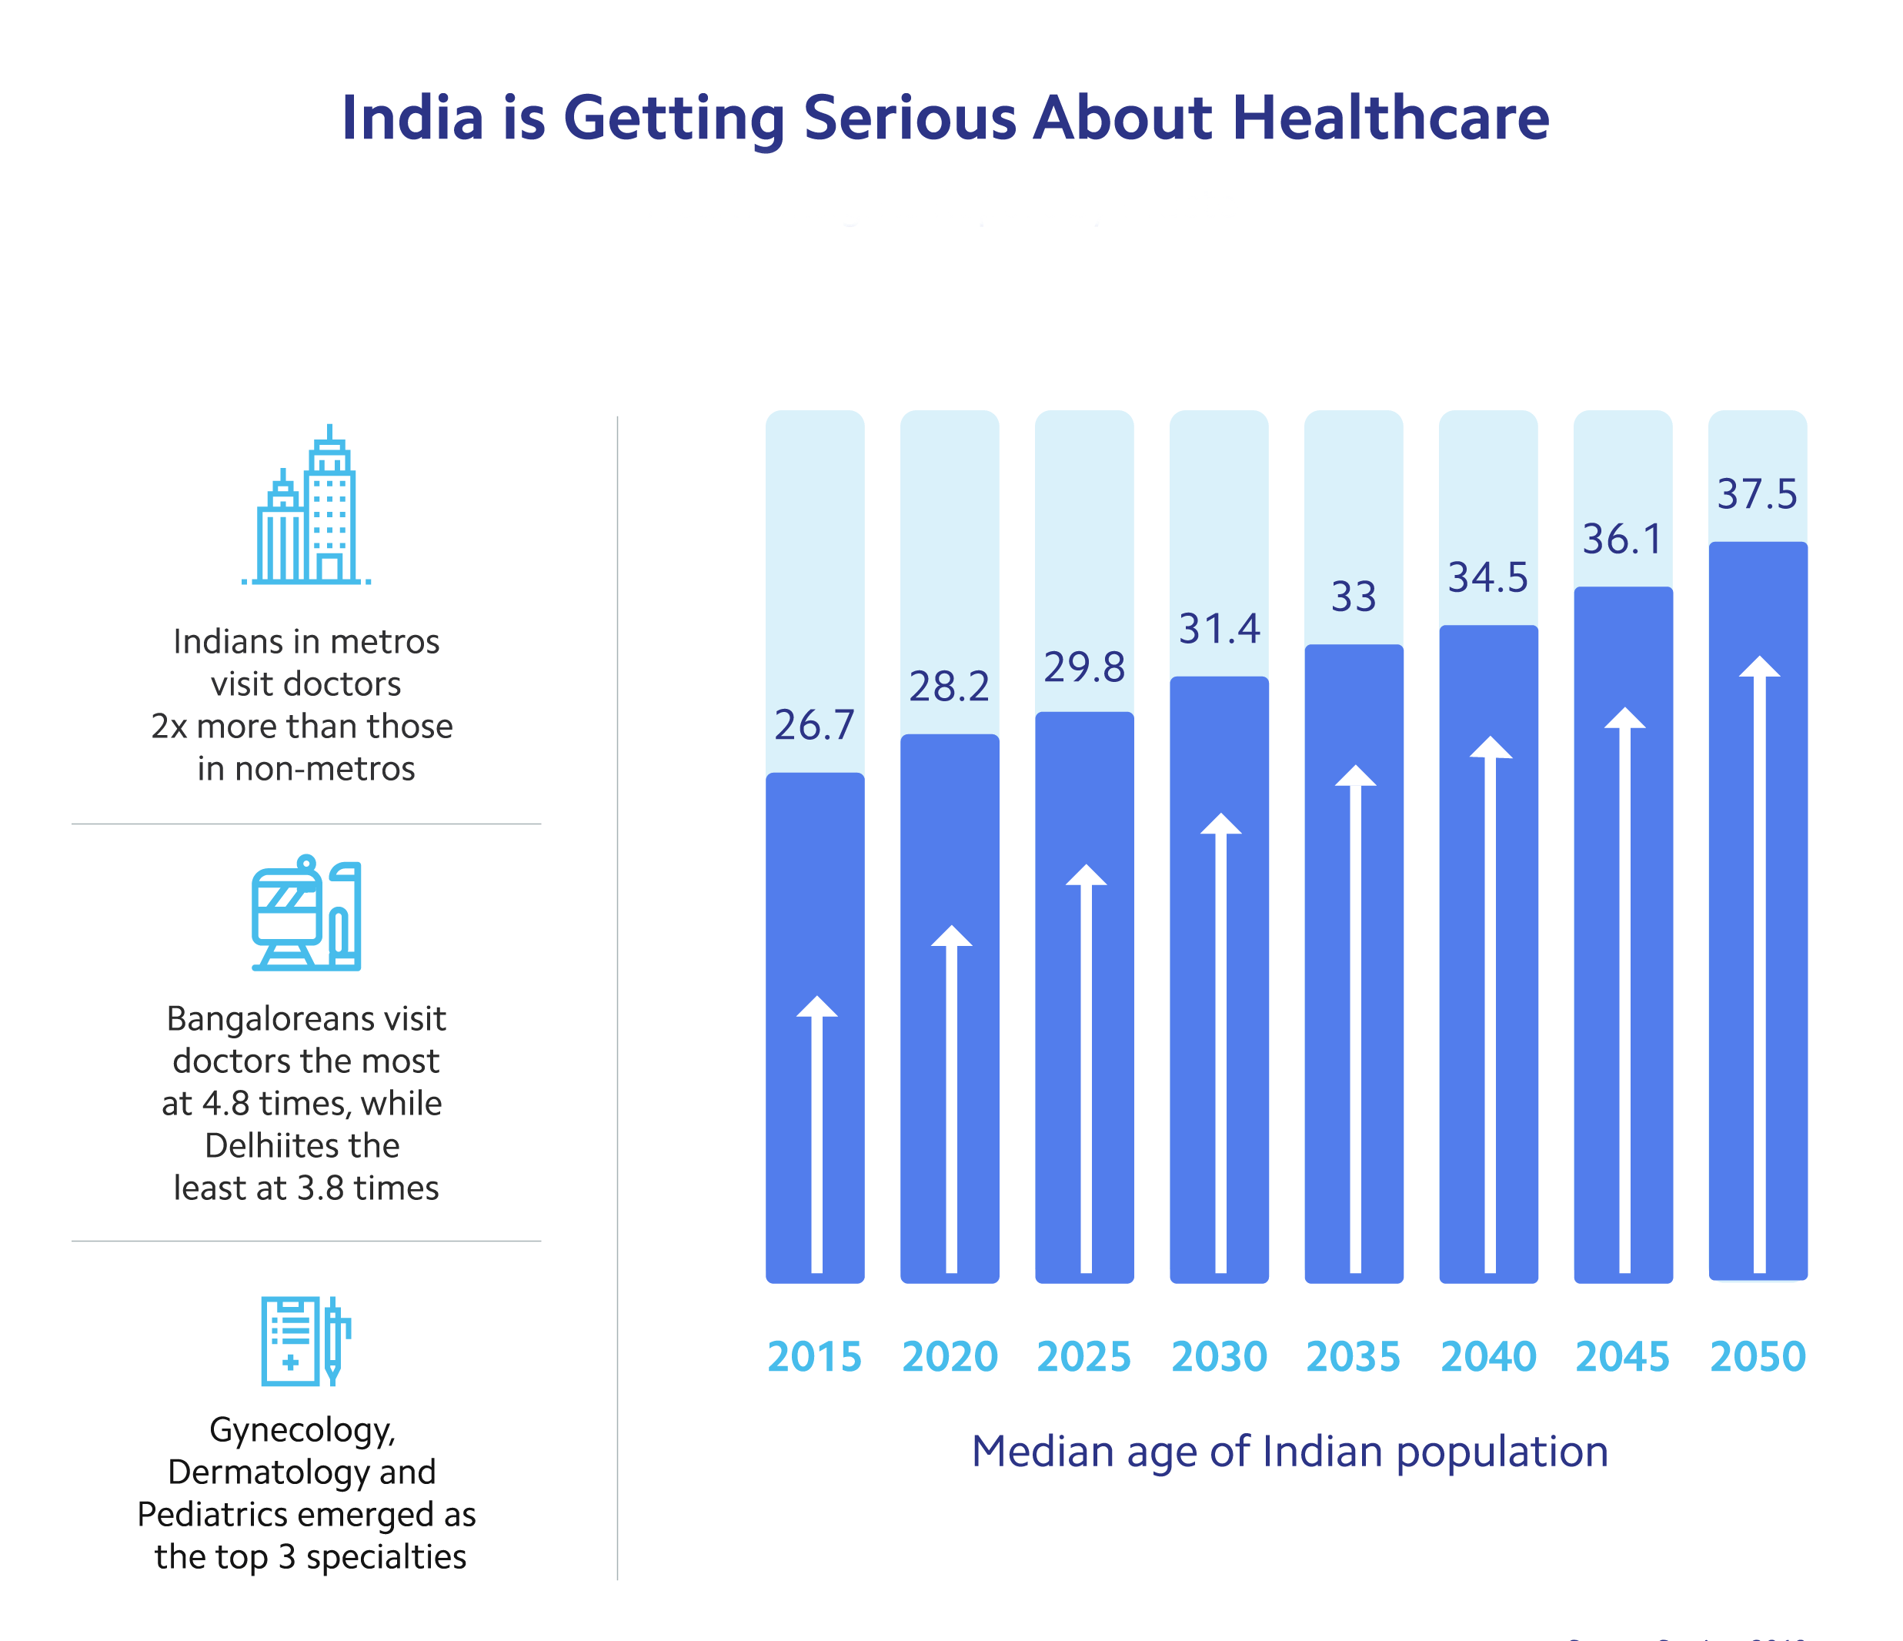

Electronic Health Records:

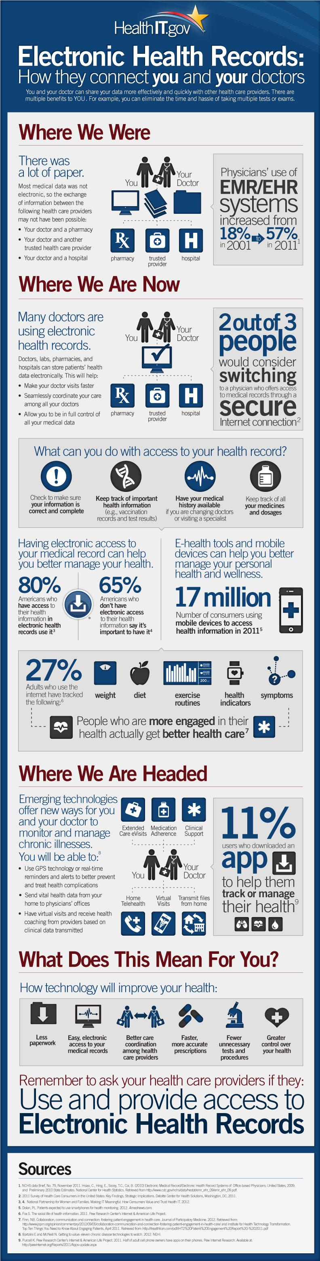

Telemedicine:
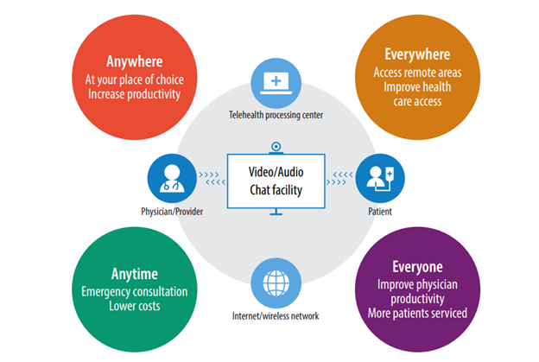
AI and Machine Learning:
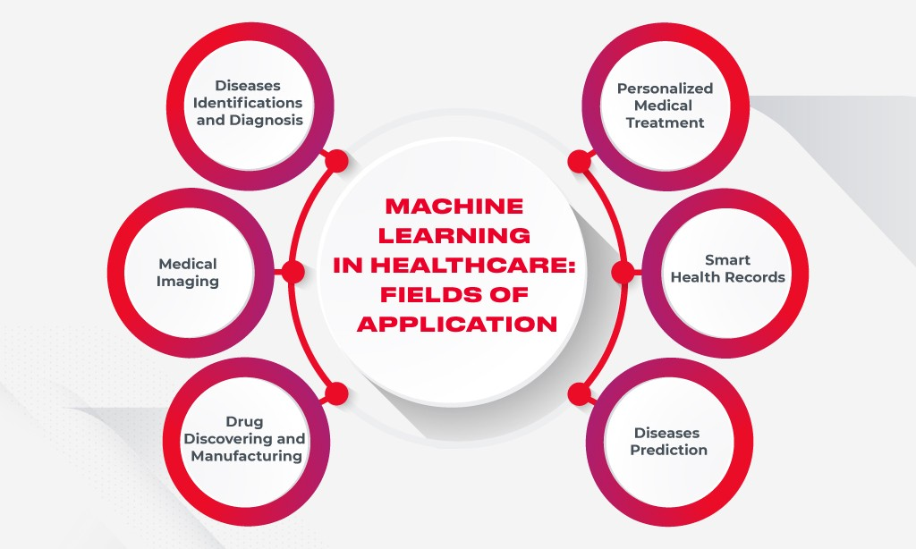
Patient centric care:
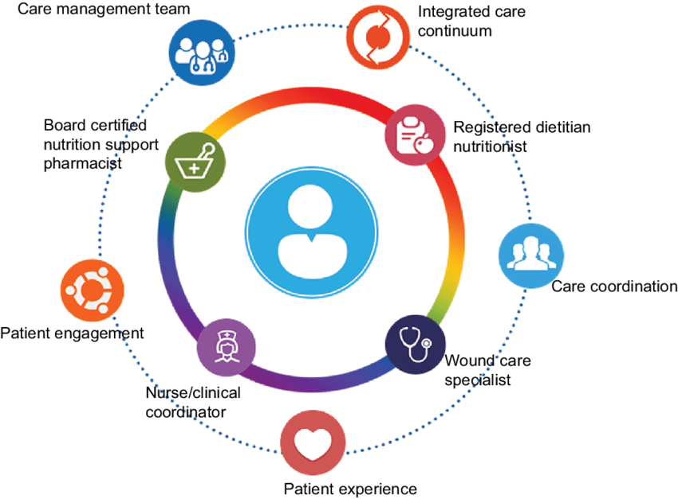

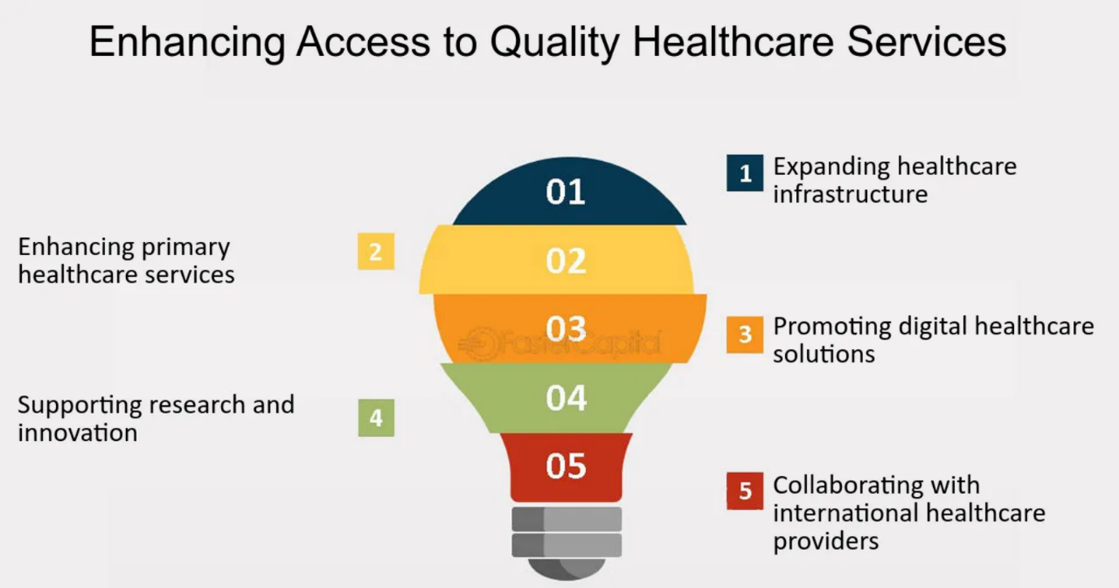

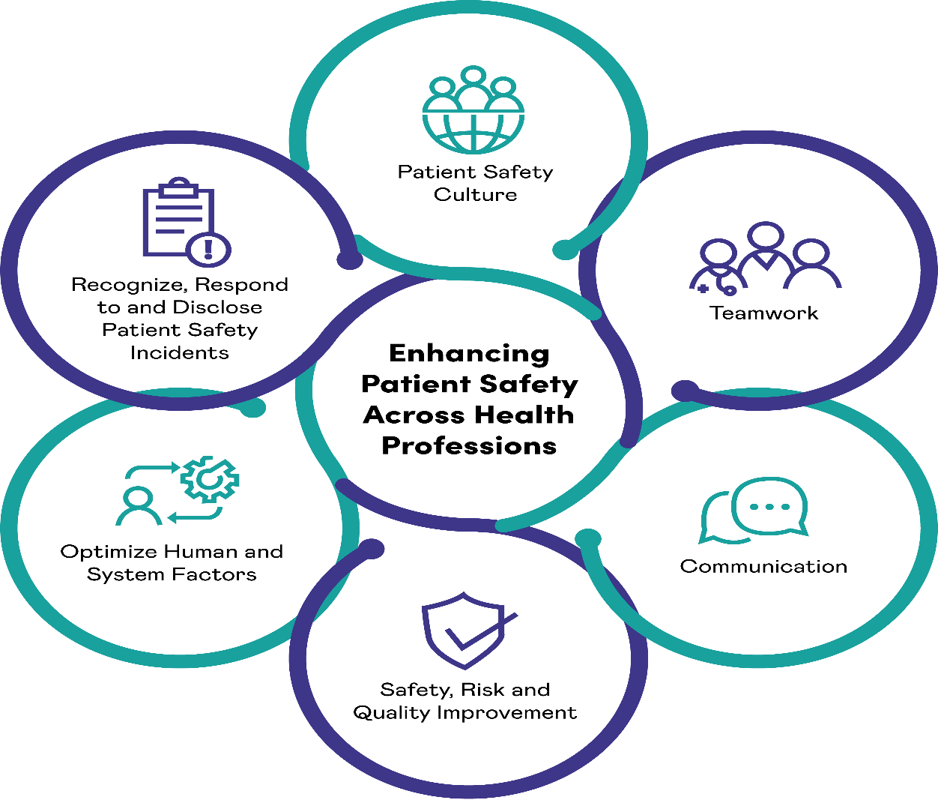

Geographical distribution of public health management institutions in India.
S. No. | State | Number of Institutions | EAG state
1 | Karnataka | 8 | No
2 | Delhi | 6 | No
3 | Maharashtra | 5 | No
4 | Uttar Pradesh | 4 | Yes
5 | Tamil Nadu | 4 | No
6 | Kerala | 3 | No
7 | Chandigarh | 2 | No
8 | Gujarat | 2 | No
9 | Rajasthan | 2 | Yes
10 | Telangana | 2 | No
11 | West Bengal | 2 | No
12 | Himachal Pradesh | 1 | No
13 | Nagaland | 1 | No
14 | Odisha | 1 | Yes
15 | Puducherry | 1 | No
 | Total | 44

Benefits of Hospital Management System:
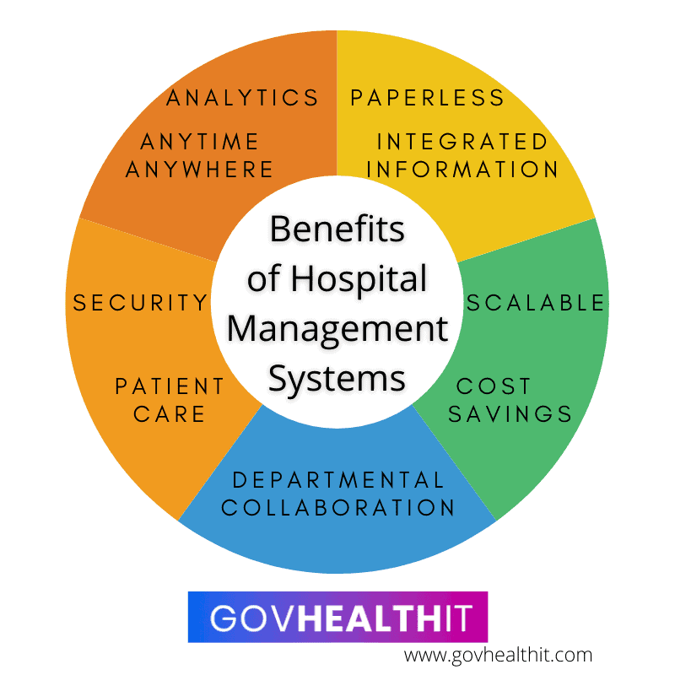

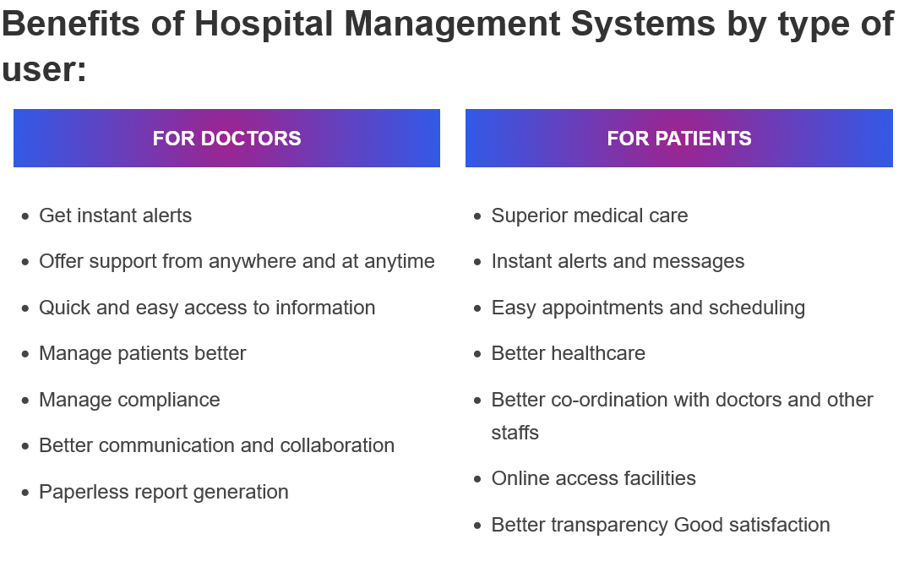
To consistently run business, hospitals and healthcare organizations must keep both the present and the future demands in sight and must adapts to changes. Change is never easy but integrating technology with hospitals to collect, manage and exchange data and monitor patients more effectively will help in creating a well-organized healthcare system, saving time, energy and cost for patients, doctors and hospital staffs.
In fact, hospitals that have implemented Hospital Management Systems have reported the following results:
• 20–30% financial savings
• Access to patient care services increased by 35%
• revenue rise of 30%
• 10% fewer trips to the emergency department
• Reduced patient wait time by 30–60%
• 20% gains in results
• 10% to 15% decrease in death rates
• 60% lower rate of hospital-acquired illnesses

As you can see, there are a ton of advantages to putting in place a hospital management system, including improved patient centred care, streamlined operations, and increased patient connectivity.

HOW INDIAN GOVERNMENT IS CONTRIBUTING IN TRANFORMATION OG HEALTHCARE SYSTEM

Ayushman Bharat, medical tourism, and the National Health Mission are a few of the main components of this constructive overhaul of India's healthcare system.
The National Urban Health Mission (NUHM) and the National Rural Health Mission (NRHM) are parts of the National Health Mission (NHM), which was established in 2013. Through the construction of new facilities, renovation of existing ones, and increased accessibility to medical supplies and equipment, the NHM seeks to enhance the infrastructure and services of primary healthcare. Additionally, this project aims to improve health-related human resources by educating and hiring additional physicians, nurses, and paramedics, particularly in rural areas. Additionally, the NHM seeks to enhance the health of expectant mothers, newborns, and children by increasing access to necessary services such prenatal care, professional birth attendance, and immunization programs. Finally, it uses focused interventions and public health initiatives to address both communicable and non-communicable diseases. For the fiscal year 2024, the National Health Mission received funding of more than 290 billion Indian rupees.
Launched in 2018, Ayushman Bharat is an additional flagship healthcare initiative. Through Health and Wellness Centres (HWCs) and the Pradhan Mantri Jan Arogya Yojana (PMJAY), this program offers financial security and health care to India's underprivileged communities. In December 2022, the number of Ayushman Bharath Health and Wellness Centres (AB-HWCs) in India was approximately 117 thousand. AB-HWCs offer teleconsultations, diagnostic services, and free critical medications. The HWCs seek to offer preventative, promotive, and curative primary healthcare services to both rural and urban populations. The HWCs provide necessary medications and diagnostic services with an emphasis on palliative care, non-communicable diseases, maternity and child health, and communicable diseases. The PMJAY health insurance program covers secondary and tertiary care hospitalization up to INR 5 lakhs per household annually. This program covers 500 million beneficiaries and aims to assist about 100 million families who are economically disadvantaged. It covers a variety of medical procedures and treatments at hospitals that are affiliated with the program. The goal of PMJAY is to lower out-of-pocket costs and increase the most vulnerable and impoverished populations in India's access to high-quality healthcare. In India, there were more than 217 thousand public health institutions as of the 2022 fiscal year. In India, outpatient departments performed over 1.4 billion services, a substantial increase over the over 1.1 billion services provided the year before.

Innovation and regulation in healthcare

India is experiencing a plethora of new healthcare developments, ranging from affordable medical gadgets to creative approaches to healthcare delivery. In the long run, these technologies could save costs and enhance healthcare outcomes. India's healthcare regulations are changing in order to guarantee patient security, encourage superior care, and keep expenses under control. The government is acting to guarantee that healthcare providers follow strict guidelines and to simplify the regulatory framework.
The government of India acknowledges that the private healthcare industry is essential to the achievement of universal health coverage. India is a popular destination for foreign patients looking for high-quality care at reasonable pricing due to its relatively inexpensive healthcare offerings. Access to healthcare, specialized services, infrastructure, and technology have all advanced significantly in the private healthcare sector. Advanced medical technology-equipped modern hospitals, clinics, and diagnostic facilities are the result of investments made by private healthcare providers. To enhance patient care, they have embraced digital advances including telemedicine, health apps, electronic medical records, and remote monitoring systems. Access to private healthcare services has been made easier by increased health insurance coverage, as a result of insurance companies working with private clinics and hospitals. Public-private partnerships have been urged by the government to improve healthcare infrastructure and access, especially in underdeveloped areas. Targeted interventions combined with cooperative efforts between the public and private sectors can aid in closing gaps and establishing a more equitable healthcare system.

MEDICAL TOURISUM
Due to its favourable reputation, availability of cutting-edge medical treatments at comparatively lower costs, availability of highly qualified medical professionals and cutting-edge technology in private hospitals that contribute to foreign exchange earnings, and availability of these factors, India has grown in popularity. In recent years, India has become a well-liked medical tourism destination, drawing patients from all over the world. The medical tourism business in India is seeing growth due to several factors such as affordable treatment, highly skilled medical staff, modern technology, a diverse range of specializations, alternative medicine, fluency in English, and convenience of trave

